**Experiment - 8**

**Aim:**

**Write programs to study usage of logical , arithmetic ,string operators in**

**Prolog.**

**Procedure:**

* **Write a predicate max(num1,num2,num3) which finds and displays maximum number from three given numbers and min(num1,num2,num3) which finds and displays minimum number of three given numbers ,use logical operators.**

**Solution:-**

Prolog Code:

domains

predicates

start

max(real,real,real)

min(real,real,real)

clauses

start:-

nl,

write("--------------------------"),nl,

write("Enter 1st number: "),readreal(N1),

write("Enter 2nd number: "),readreal(N2),

write("Enter 3rd number: "),readreal(N3),nl,

write("--------------------------"),nl,

max(N1,N2,N3),min(N1,N2,N3),

write("--------------------------"),nl.

max(N1,N2,N3):-

N1>N2, N1>N3 ,write("Maximum: ",N1),nl.

max(N1,N2,N3):-

N1>N2,write("Maximum: ",N3),nl.

max(_,N2,N3):-

N2>N3,write("Maximum: ",N2),nl.

max(_,_,N3):-

write("Maximum: ",N3),nl.

min(N1,N2,N3):-

N1<N2, N1<N3 ,write("Minimum: " ,N1),nl.

min(N1,N2,N3):-

N1<N2,write("Minimum: ",N3),nl.

min(_,N2,N3):-

N2<N3,write("Minimum: ",N2),nl.

min(_,_,N3):-

write("Minimum: " ,N3),nl.

Output Screenshots:

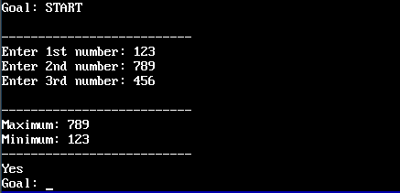

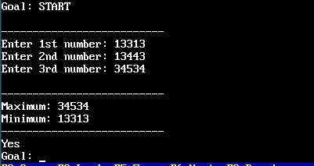

* **Write a predicate which accepts integer number as an input and displays its square .It should also find its positive square root value ,if its sqrt is integer, otherwise display ‘NA’ .Use arithmetic operators /in-built conversion predicates to achieve this.**

**Solution:-**

Prolog Code:

domains

predicates

start

square(integer)

squroot(integer)

clauses

start:-

nl,

write("-------------------------------"),nl,

write("Enter the positive number: "),readint(N),

square(N),squroot(N),

write("-------------------------------"),nl,nl.

square(N):-

S=N*N,

write("-------------------------------"),nl,

write("Square is: ",S),nl.

squroot(N):-

Y=sqrt(N),

Z=round(Y),

Y=Z,

write("Square Root: ",Y),nl.

Squroot(N):-

Y=sqrt(N),

Z=round(Y),

not(Y=Z),

write("Square Root: NA "),nl.

Output Screenshots:

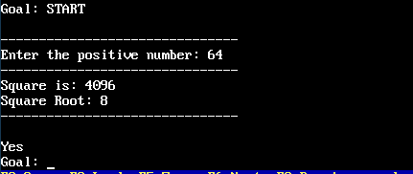

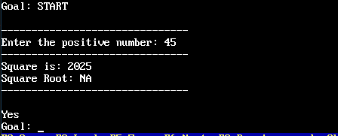

* **Write a program to find substring from a given string. The substring should start from 1st location of source string and should contain the entered number of characters from the source string.**

**Solution:-**

Prolog Code:

predicates

start

go1

go2

go3

go4

clauses

start:-

write("Enter the string : "),readln(X),nl,

write("Enter number of char needed in substring:"),readint(N),nl,

frontstr(N,X,Y,Z),

write("Original string is:",X),nl,

write("Substring is:",Y),nl,

write("Remaining string is:",Z),nl.

go1:-

write("Enter the String: "),readln(S),

fronttoken(S,A,B),

write(A),nl,write(B),nl.

go2:-

write("Enter the String: "),readln(S),

upper_lower(S,A),

write("Lower case String: ",A),nl,

upper_lower(B,A),

write("Upper case String: ",B),nl.

go3:-

write("Enter the String: "),readln(S),

str_len(S,A),

write("The length of the string is: ",A),nl.

go4:-

write("Enter the first String: "),readln(S1),

write("Enter the second String: "),readln(S2),

concat(S1,S2,S),

write("Concated String: ",S),nl.

Output Screenshots:

